Human Physiology Quiz #1, 2015 KEY Name___________________________

Select the BEST answer for the multiple choice questions.
1) 4 points Hyperpolarization (becoming more negatively charged) of an axon during an action potential is usually caused by
a. diffusion of K+ out of the axon
b. diffusion of Na+ into the axon
c. diffusion of K+ into the axon
d. diffusion of Na+ out of the axon
2) 4 points The central nervous system includes the
a. afferent nerves and spinal cord.
b. efferent nerves and spinal cord.
c. |  | autonomic nervous system and the brain.
d. |  | brainstem and the autonomic nervous system.
e. |  | brain and spinal cord.

3) 4 pts (partial credit allowed) The sensory division of the nervous system is composed primarily of __________ (unipolar, multipolar, bipolar) nerves that connect to the central nervous system through the ______________ (dorsal root, ventral root, apical root) ganglion.

4) 4 pts (partial credit allowed) Calculate the concentration of potassium (K) that is required outside of a cell to maintain an equilibrium membrane potential of -94 mV if the concentration of K inside the cell is 105 mM. Show all of your calculations and formulas. Assume the cell is freely permeable only to K.

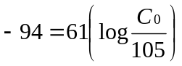

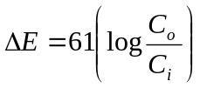
= 3 mM

5) 4 pts (partial credit allowed) Calculate the membrane potential difference given the following conditions:
[Na] inside the cell = 14 [K] inside the cell = 140
[Na] outside the cell = 142 [K] outside the cell = 4
Na permeability = 200 K permeability = 1
Show all of your calculations and equations.
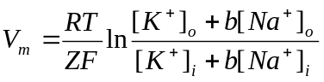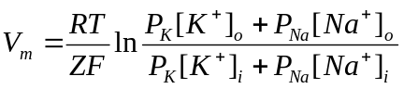
or

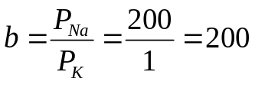

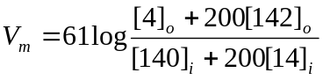 V _{m} = 60 mV

